KUNAL JHINDAL (24070126098)-AIMLB1
ASSIGNMENT-1
Design and implement a Java program that performs arithmetic operations using a menu-driven approach with proper user input validation and modular methods.
CODE:
import java.util.Scanner;

public class Calculator {

public static int addnums(int n1, int n2) {
return n1 + n2;
}

public static int subnums(int n1, int n2) {
return n1 - n2;
}

public static long mulnums(int n1, int n2) {
return (long) n1 * n2;
}

public static float divnums(int n1, int n2) {
return (float) n1 / n2;
}

public static int modulus(int n1, int n2) {
return n1 % n2;
}

public static void main(String[] args) {
Scanner scan = new Scanner(System.in);
int opr;

do {
System.out.println("\n--- Calculator Menu ---");
System.out.println("0. Exit");
System.out.println("1. Addition");
System.out.println("2. Subtraction");
System.out.println("3. Multiplication");
System.out.println("4. Division");
System.out.println("5. Modulus");
System.out.print("Enter your choice: ");

opr = scan.nextInt();

if (opr == 0) {
System.out.println("Exiting Calculator...");
break;
}

System.out.print("Enter first number: ");
int n1 = scan.nextInt();

System.out.print("Enter second number: ");
int n2 = scan.nextInt();

switch (opr) {
case 1:
System.out.println("Sum = " + addnums(n1, n2));
break;
case 2:
System.out.println("Difference = " + subnums(n1, n2));
break;
case 3:
System.out.println("Product = " + mulnums(n1, n2));
break;
case 4:
System.out.println("Quotient = " + divnums(n1, n2));
break;
case 5:
System.out.println("Remainder = " + modulus(n1, n2));
break;
default:
System.out.println("Invalid choice!");
}

} while (true);

scan.close();
}
}

OUTPUT:
- Addition
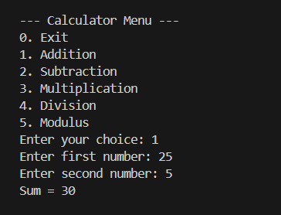
(b) Subtraction
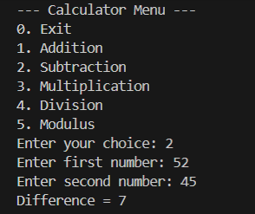
(c) Multiplication
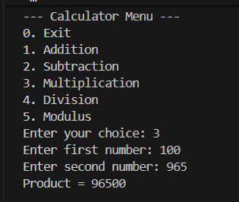

(d)Division
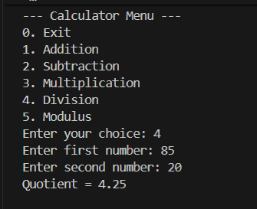
(e) Division with n2 as 0
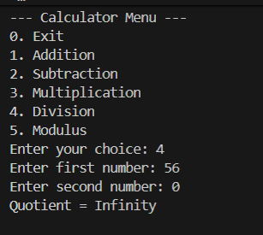
(f) No valid input of number
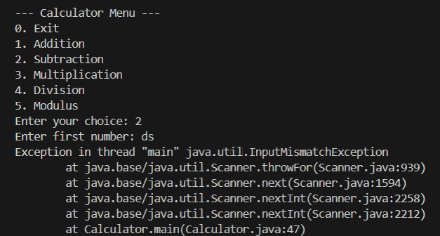

(g) No valid input of the operator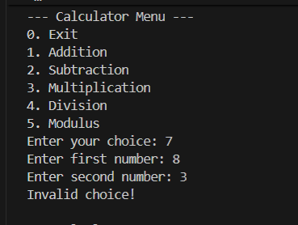
(h) Exiting
